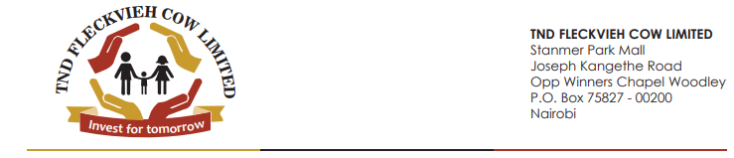

The Principal Secretary,

State Department for Livestock Development, 11.11.2020

Ministry of Agriculture, Livestock, Fisheries and Cooperatives,

P.O. Box 34188 – 00100.

Nairobi.

Dear Sir/Madam,

**RE: PUBLIC-PRIVATE PARTNERSHIP (PPP) FOR UNLOCKING THE POTENTIAL OF DAIRY CATTLE PRODUCTIVITY IN KENYA FOR IMPROVED LIVELIHOODS**.

On behalf of my investment group I write this letter to you to allow us do business which will make KENYA food secure.

No KENYAN will ever die because of hunger.

Our business will help eradicate poverty and will unite all the people of Kenya.

KENYA will be a lender to other nations. Our main mission is to lead all KENYANS to CANAAN- the land of milk and honey using this political party - THE NEW DEMOCRATS (TND) whose registration number in the Office of the Registrar of Political Parties is 40 and her SYMBOL is a BRIDGE designed with 42 pillars where each pillar represents a tribe in KENYA each living in the 42 cities God had told Moses to set aside for the Levites (Numbers 35:6-7).

THE NEW DEMOCARTS (TND) is using the cooperative society model to benefit her members and is open to any other willing person. TND has partnership with international consortiums. Among them is Almarai of the Kingdom of Saudi Arabia. Attached here is the execution. Kindly allow us the permission to operate in the locations mentioned.

Yours sincerely,

Hon David Sudi EBS,

National Chairman.

TND FLECKVIEH COW LIMITED.